Bella Davies, Frederic Lemonnier, Eugenia Lim, Virushi Patel, Madhri Yehiya, Enzo Yumiketa

MA 213 Basic Statistics and Probability

Prof. Salins

19 Nov. 2021

Final Report

Our study was created from a question each of us already had prior to being asked to research a topic of interest for MA213. As members of the Class of 2024 who all live within BU Housing, some of which is located on the ends of the campus, we wondered if living off campus would be cheaper despite the farther distance. The variables of interest for us were mainly food and transportation, although rent and utilities are noteworthy as well. In an effort to account for them, we asked respondents to record their total weekly expenses in addition to the amount spent on food and transportation per week. We then studied the relationship between students’ weekly spending and where they live at Boston University. Examining as many relevant factors as possible such as the type of transportation and how many meals they ate per day helped us to determine whether it is more cost effective to live in an on campus residence or an off campus apartment, with the deciding factor being physical distance from the College of Arts and Sciences. Although our results surprised us to some degree, we are hopeful that our data can provide some insight on the debate of on campus versus off campus for our audience of BU students. The results of our study could also help to support the argument that the University should charge students less for living in dorms located farther away, given the added expenses of living there caused by the need for food and transportation. With the hope to confirm the hypothesis that the dorm location on campus determines how much a student spends per week, we sent out a Google Forms survey.

The null hypothesis, or H0, for our experiment is that there is no significant difference in money spent on transportation for those that live on or off campus, greater than or less than 0.5 miles away from Central Campus, defined as the College of Arts and Sciences building. The alternate hypothesis, or Ha, is that students who live greater than 0.5 miles away from Central Campus, on or off campus, spend more on food and transportation than those within 0.5 miles of Central Campus. Upon reviewing our preliminary data, we noticed several areas where improvements could be made in terms of questioning style and response options. This included an “Other” option when asking for a year of graduation, which opened up the question to false answers and respondents writing out if they were a freshman, sophomore, junior or senior rather than selecting their graduation year. For the question on housing selection, we realized including an “Other” option would be helpful in case we forgot to include one or more. Although we had thought at the time that the survey was fairly well done, the extremely basic nature of the information we collected demonstrated that a more specific line of questioning would deepen our understanding and analysis of our research question. We decided to ask which dining plan each individual student has to figure out how each choice would affect their spending on groceries and eating out. The type of transportation the respondent spent money on as the cost of Uber vs. the T vs. Blue Bikes also became of interest at this stage. Finally, we changed almost all questions to a short answer format rather than multiple choice ranges in order to efficiently conduct statistical experiments and analyze the data in graphical format.

**Experimental Methods**

In order to conduct our study, we sent out a Google forms survey to hundreds of students in order to yield an adequate sample size, eventually ending with 109 respondents total. We sent our form to several student organizations, sports teams and peers in our own dorms on campus. At first, a majority of responses came from students in the Class of 2024 which was unfortunately to be expected given our group’s demographic. In the final version of our survey, we asked participants how much they spent on food and transportation in a week, as well as in total per week. We asked the students not only whether they live on or off campus, but also how far their distance was from CAS in order to measure if distance plays a role in increased spending. We classified students living greater than 0.5 miles from this point as considered far. To properly account for the cost of food when paying for a dining plan, we included on-campus students’ dining plans to the value of total spending to compare it to off-campus students’ spending on groceries and eating out. This value was calculated by dividing the cost of a given student’s dining plan (another question asked on the survey) by 15 weeks in a semester to find the cost of food per week.

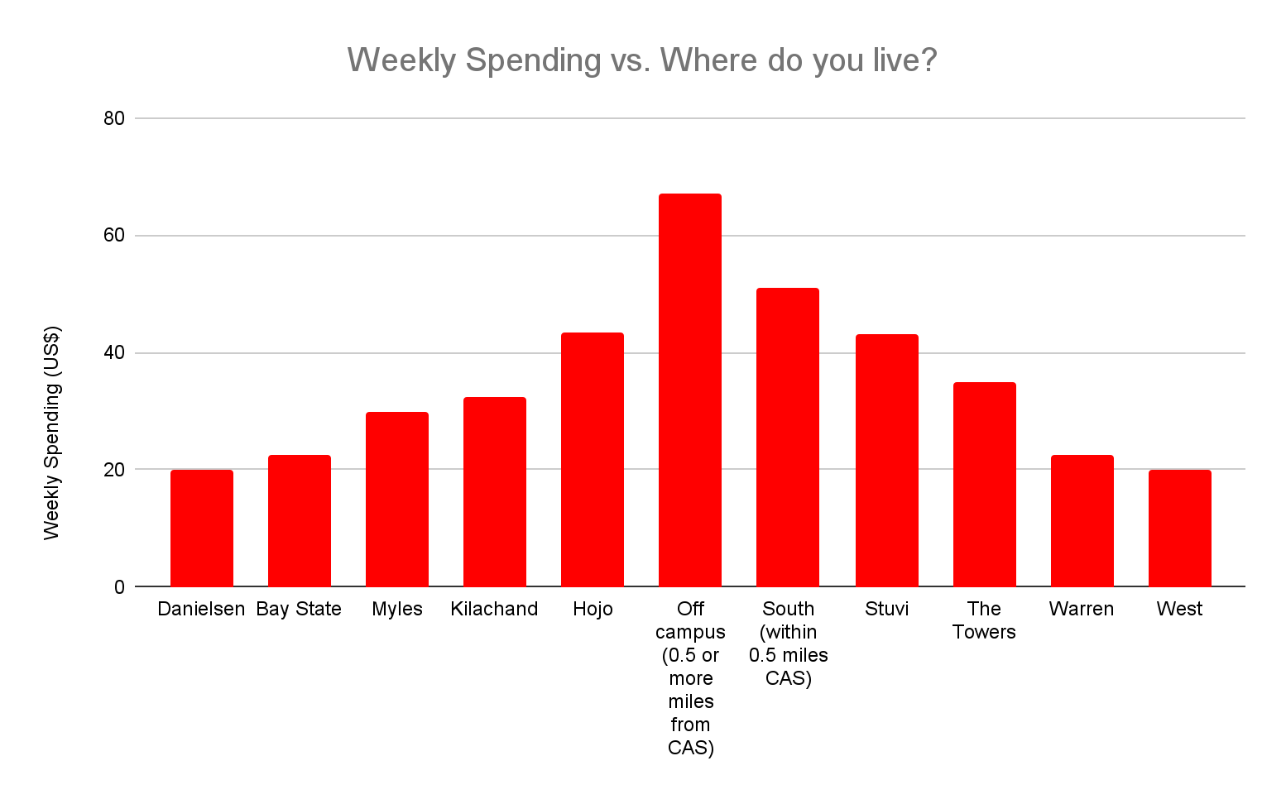

*Graph 1: Weekly Spending vs Where do you live?*

In order to construct the graph above, we categorized the independent variable into 11 sections: Danielsen Hall, Bay State Road, Myles Standish Hall, Kilachand Hall, “HoJo”, Off Campus (0.5 or more miles from CAS), South (within 0.5 miles from CAS), Stuvi, Towers, Warren, and West. The graph depicts the average weekly spending of students, and we were able to observe a difference in the results based on distance from Central Campus. For example, students living in locations such as Danielsen Hall, Bay State Road, Warren Towers and West, had a weekly spending of almost half the average student living off campus or in the South. We found if a student lives off campus 0.5 miles or more from CAS, it is most likely that this student has an average weekly spending higher than other students living on campus.

One of the main problems we encountered when creating a graph was organizing the data collected into their appropriate categories. At the conclusion of our data collection, instead of having exactly 11 categories, there were more than 25 total, which forced us to manually organize the data into their proper categories. Throughout the process of collecting and analyzing the data, our group encountered some difficulties, but with minor inconvenience we were able to overcome them by remaking and adjusting our graphs to answer the main question.

**Results**

In order to analyze the validity of our results, we implemented the Large, Independent Samples Test of Hypothesis for (μ1 - μ2). Our two target populations of students living on and off campus were randomly selected in an independent manner and both of a size greater than n=30, allowing us to conduct this test. In order to verify our claim that living off campus is cheaper than living on campus, we referred to the null and alternative hypothesis and performed a one-sided test. Below, μ1 indicates the average weekly total of on-campus students and μ2 indicates the average weekly total of off-campus students.

H0 : ( μ1 - μ2 ) = 0

H1 : ( μ1 - μ2 ) > 0

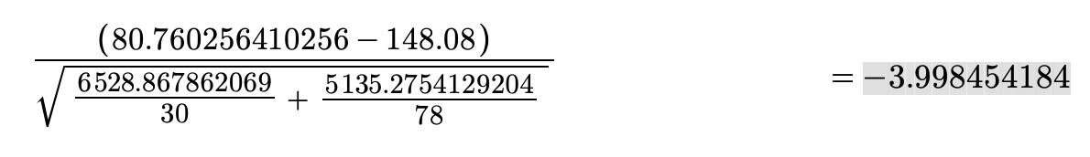

The alternative hypothesis states that the difference between living off campus and on campus should be greater than zero meaning that living off campus is cheaper than living on campus. The calculated test statistic Z Value was −3.998454184. At *α* = 0.01, the z-value is 2.576. The rejection region for Zc is any value greater than 2.576. Since 2.576 is greater than -3.998, which shows that Zc doesn’t fall in the rejection region. Therefore at *α* = 0.01 we cannot reject the null hypothesis and demonstrate evidence of on or off campus being cheaper than one or the other, regardless of distance from Central Campus.

Based on our data, it cannot be concretely shown that living further away from Central Campus means that a student will spend more weekly. Myles — being one of the farthest on campus housing options from CAS — has the most average of weekly spending of $340.75 in comparison to Danielsen, where student’s weekly spending averaged about $223 despite being located even further east. This specific comparison suggests that distance does not have as significant of a correlation to weekly spending as we initially expected. Demographically speaking, it is interesting to note that while students of the Class of 2022 and 2025 have a weekly average total of $140.10 and $141.00 respectively, students in the Class of 2023 and 2024 have a weekly average of $71.70 and $115.00. Seniors also generally prefer to live off campus and first-year students are required by the University to live on campus unless they are a daily commuter, yet both the weekly averages are practically the same. Additionally, our results yielded a vast range in terms of the total weekly expenses. We calculated the Confidence Interval to obtain a range of values that were likely to include the population’s value with a certain degree of confidence. The mean for the weekly total was $108.73 and the standard deviation $132.4, in dollar terms. Hence, we conclude with 99% confidence the population mean is between $76.00 and $141.00, based on 109 samples.

**Analysis**

Our original hypothesis is confirmed to be wrong as there is no significant difference in money spent on transportation for those that live on or off campus, greater than or less than 0.5 miles away from Central Campus, defined as the College of Arts and Sciences building. This could be due to a few factors we had not considered, such as housing costs for on-campus students and apartment rent for off-campus students. If we had phrased our questions to ask for the monthly cost of on and off campus student housing, more students would have likely remembered to take into consideration monthly rent and utilities on top of total expenses. Furthermore, we did not think to consider each student’s financial aid or scholarships they may receive and how that may affect their actual out-of-pocket total spending on housing and dining. These factors were unfortunately not taken into consideration when trying to tackle the main question of our research, and it may have impacted our data significantly.

**Conclusion**

We are unable to reject the null hypothesis as there is a lack of significant difference between money spent by on-campus residents versus off-campus residents. Perhaps if we had been able to compare the monthly cost of BU Housing to that of monthly off campus rent, the spending statistics used to compare would have been more accurate. It is also possible that there is a difference in the amount spent each season, so the cost could differ from one living space to another depending on the time of year. Finally, our survey should have asked more questions regarding the demographics of our respondents such as their gender, major, race, income level, and whether or not they are international students in order to evaluate any interesting trends based on the background of a given respondent. However, if this study were to continue, it would be more effective to collect and analyze the data over a longer period of time in order to achieve more successful and conclusive results.